Steps to customize the Sourcing Notification Title via BPM Task Configuration:
You can configure notification title. This is a step by step guide to configure title for Sourcing Notifications using Task Configuration in the BPM worklist. In this example, we will configure a notification title for Negotiation Approval notification.
Previous Title – ‘Negotiation submitted for approval’
New Title – ‘Solicitation submitted for approval’

- Click on the ‘Show All’ link under the bell icon to open the complete list of notifications.

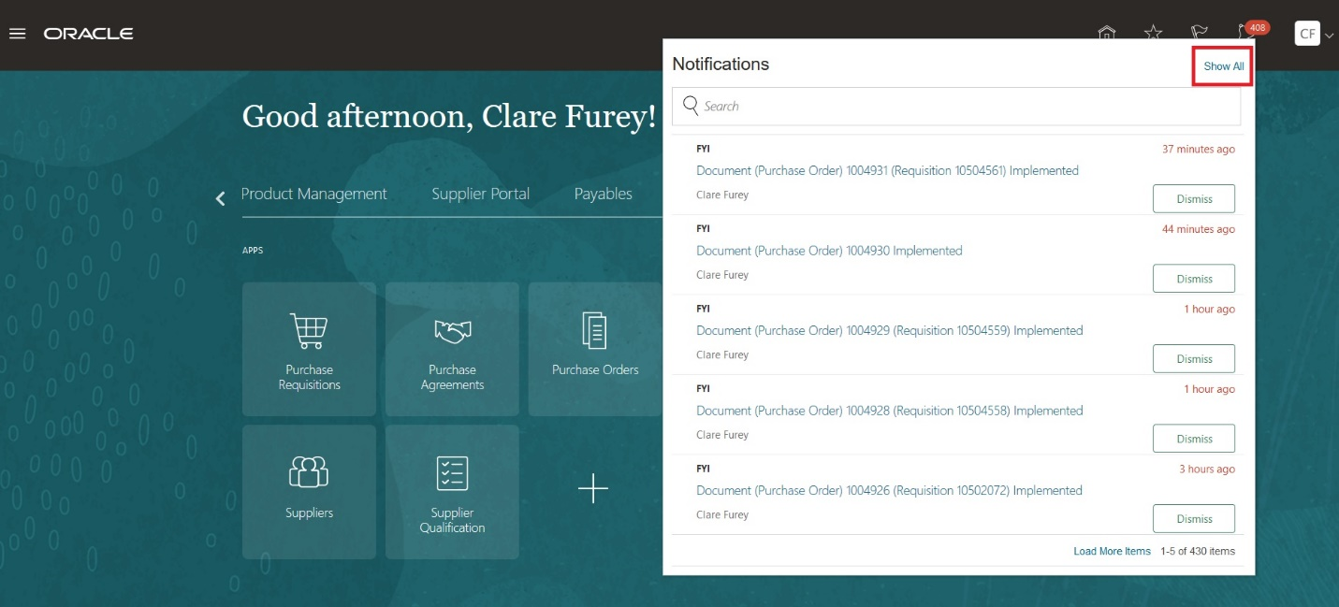

- Click on the ‘Worklist’ to open the BPM worklist.

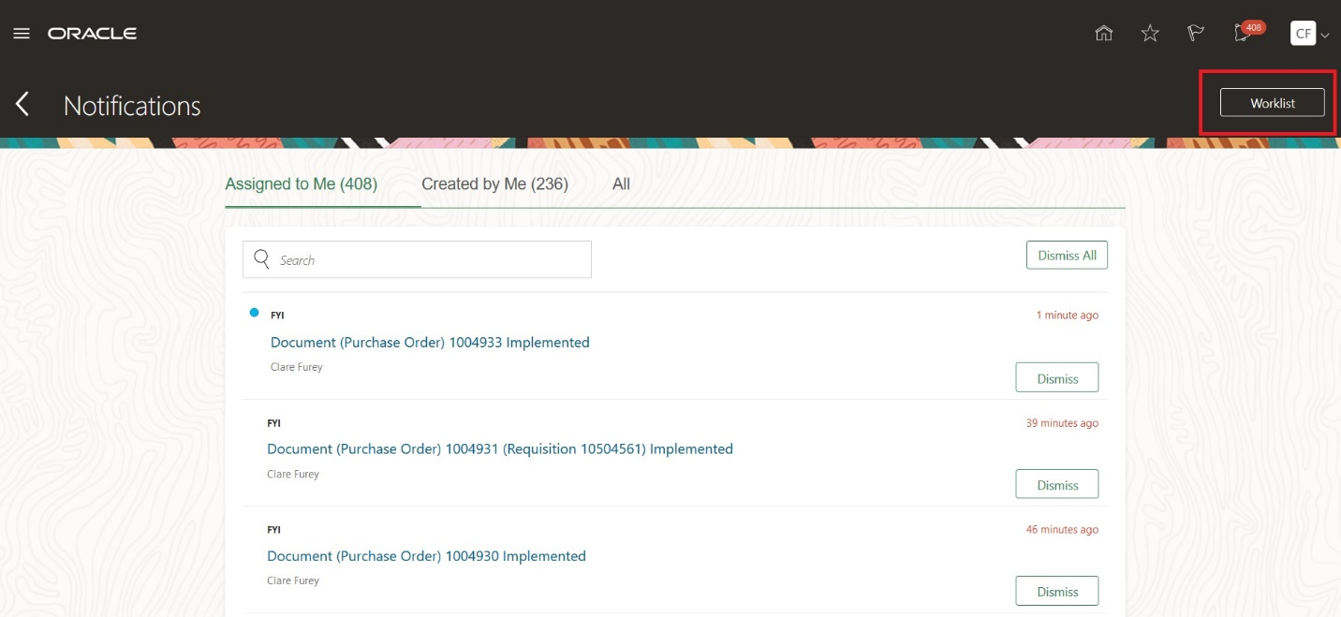

- Click on ‘Administration’ from the drop down menu as shown below.

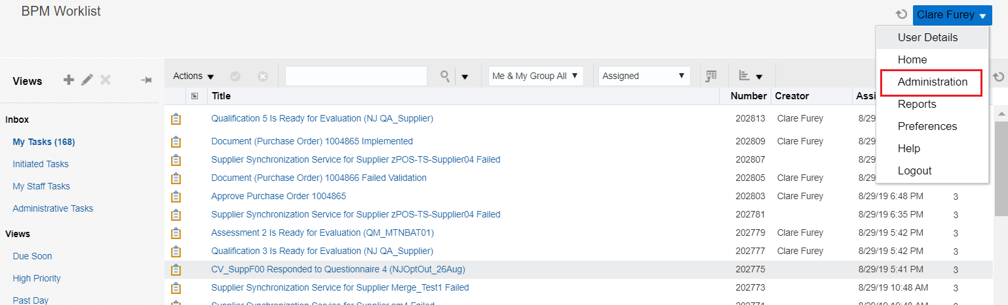

- Click on the ‘Task configuration’

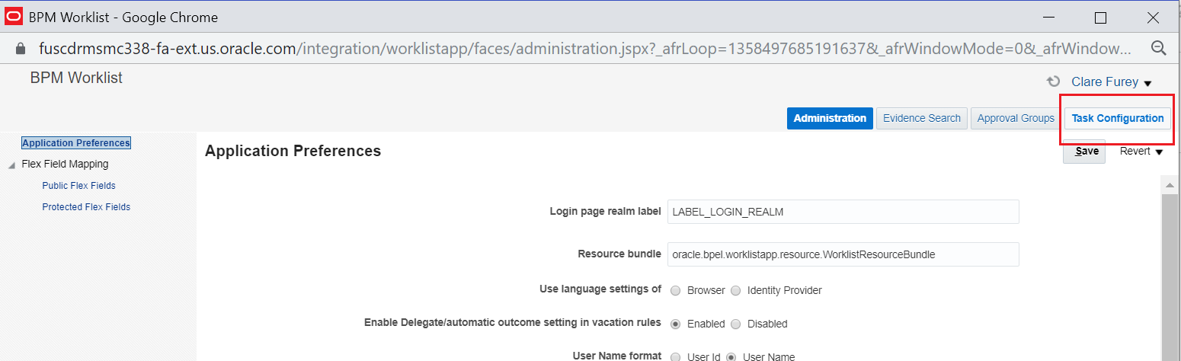

- In the task configuration left pane, search for *NegotiationApproval*

From the search results retrieved, select the task from the list and click on ‘Edit’ icon.
Click on the globe icon beside Title.
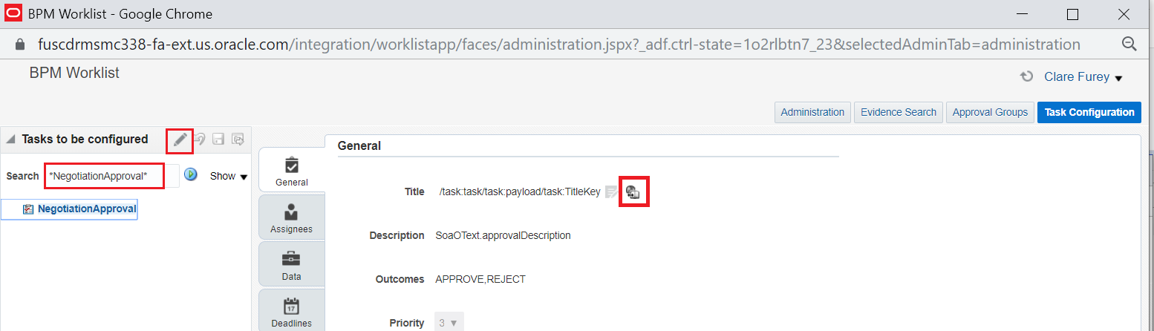
- Click on + icon and give a key and the new title. In the below example, {0} and {1} are the arguments whose values can be set from available list of variables.

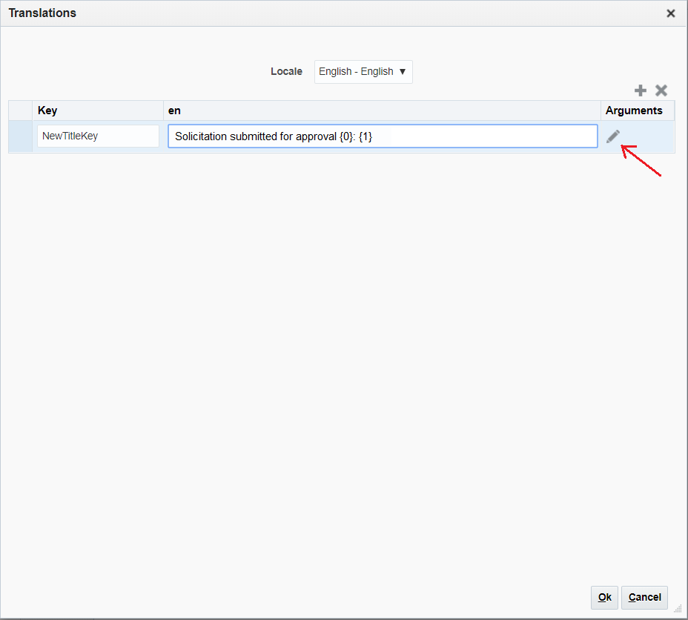

- Click on the edit icon beside the value column to insert variables into expression.

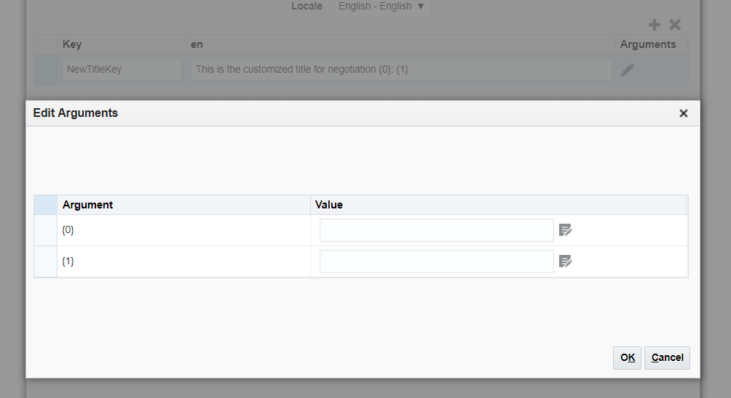

- Select the required variable from the available list from the left panel.
(e.g. NegotiationNumber has been selected below)

Thereafter, click on Insert into Expression.

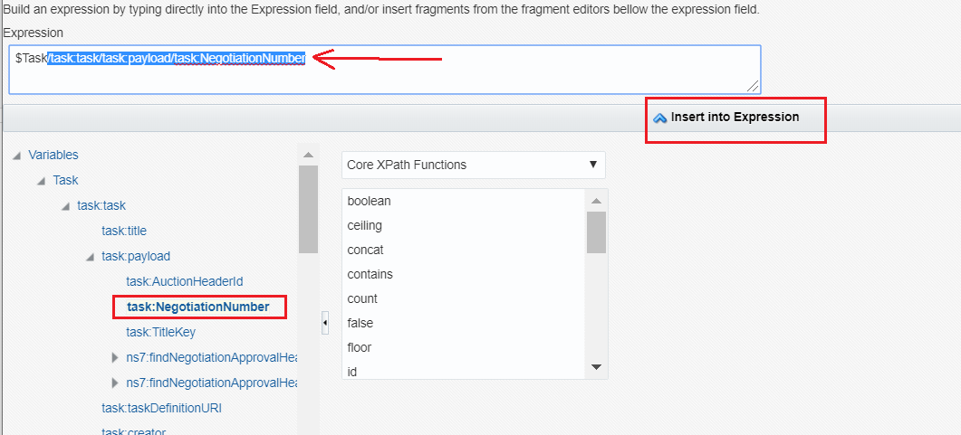

- Check the expression that is created. Follow the same to set value for {1} and click on ‘OK’.

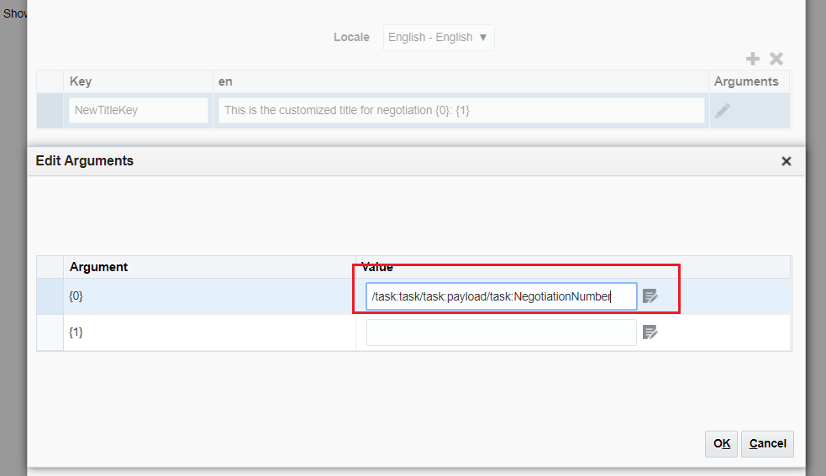

- Notice that the title now shows the newly created key.
After confirming the changes click on ‘Commit’ icon for the changes to take effect.

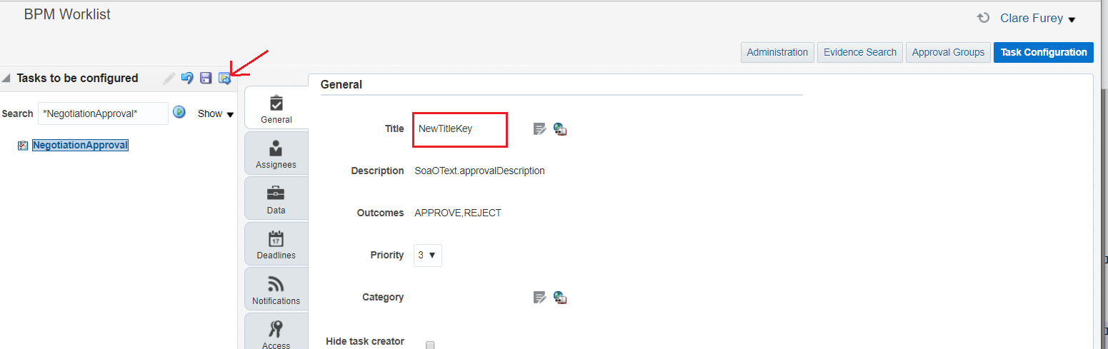
Note:*
- Changes once done to the notification title cannot be undone. In order to revert to original subject, follow the same steps mentioned for customization and manually update the subject to reflect the old one.
- Notifications sent to additional email recipients which are not work flow notifications cannot be customized this way.

Appendix

Summary
This article describes how a user can configure Sourcing Notification Title via BPM Task Configuration as per the business needs.
Content
You can configure Sourcing notification title to suit your business using BPM Task configuration. The below notifications with Human Task names can be configured:
Internal Notifications
Notification | BPM Task Name
Notification sent to an approver to approve or reject the award decision for a negotiation, as per the approval rules. | AwardApproval
Notification sent by the approver to the buyer stating whether award decision is approved or rejected. | AwardApprovalStatusFyi
When a task is assigned in a negotiation to a collaboration team member. | CollabTaskAssignNotifFyi
When the task assigned to a collaboration team members is completed (manually/automatically). | CollabTaskCompleteNotifFyi
Notification sent to an approver when a negotiation is published, as per the approval rules. | NegotiationApproval
Notification sent by approver to buyer stating whether the negotiation is approved or rejected. | NegApprovalStatusFYI
When a negotiation is created. | NegotiationCreatedFyi
When an online message is sent to the buyer. | OnlineMsgNotifBuyerFyi

External Notifications (Negotiations)
Notification | BPM Task Name
Notification sent to a supplier to communicate award decision. | AwardDecisionNotifFyi
Notification sent to a supplier when a negotiation is cancelled. | CancelNegNotifFyi
Notification sent to a supplier when his bid is disqualified in a negotiation. | DisqualifyRespNotifFyi
Notification sent to a supplier when he is invited to bid for a negotiation. | InviteSupplierRequestForAction
When an online message has is to the supplier | OnlineMsgNotifFyi
Notification sent from a supplier to a buyer, when a supplier has submitted a response to a negotiation. | SubmitRespNotifFyi
Notification sent to an uninvited supplier for a new round. | UninvitedSupplierNewRoundFyi

External Notifications (Seller Negotiations)
Notification | BPM Task Name
Notification sent to a bidder when a seller negotiation is published. | PublishSellerNegNotifFyi
Notification sent to a bidder to communicate award decision for a seller negotiation. | SellerAwardDecisionNotifyFyi
Notification sent to a bidder when his bid is disqualified in a seller negotiation. | DisqualifyBidFyi
Notification sent to a supplier when a negotiation is either closed/paused/resumed or extended. | SellerScheduleActionsNotifFyi

Please refer to attached document for step by step process to customize Notification title using BPM Task configuration.
Note:*
- Changes once done to the notification title cannot be undone. In order to revert to original subject, follow the same steps mentioned for customization and manually update the subject to reflect the old one.
- Notifications sent to additional email recipients which are not work flow notifications cannot be customized this way.

